Agentic AI
05.07.2025

Agentic AI
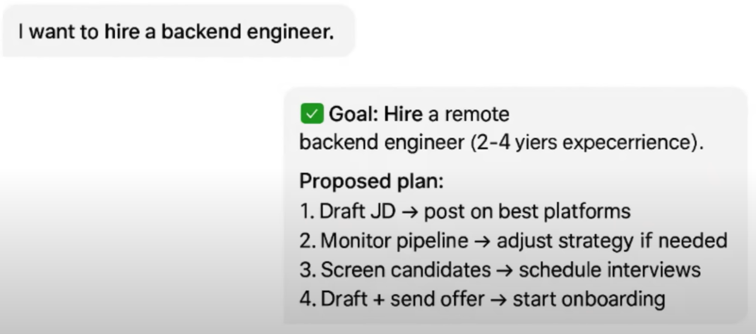
Agentic AI is a type of AI that can take up a task or goal from a user and then work toward completing it on its own , with minimal human guidance. It plans , takes action , adapts to changes , and seeks help only when necessary.
E.g.

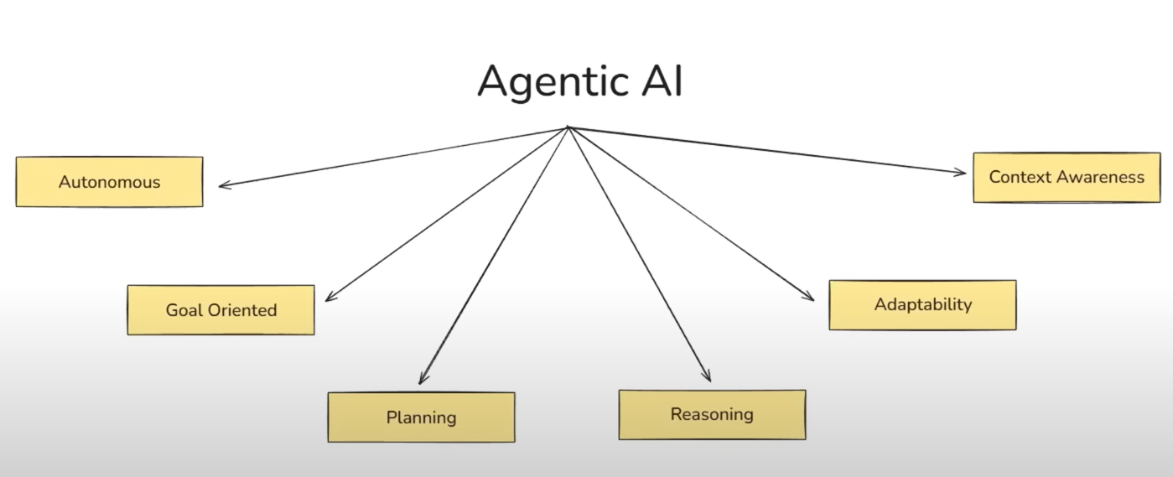
Key characteristics of Agentic AI :

Autonomy
Autonomy refers to the AI’s system’s ability to make decisions and take actions on its own to achieve a given goal , without needing step by step human instructions.
Autonomy can be controlled because more autonomy can be dangerous.

Goal Oriented
Being goal oriented means that the AI system operates with a persistent objective in mind and continuously directs its actions to achieve that objective. Goals can come with constraints , can be stored in core memory , and can also be altered. They are stored in JSON format.

Planning
Planning is the agent's ability to break down a high level goal into a structured sequence of actions or subgoals and decide the best path to achieve the desired outcome. We have a loop of planning and execution. The agent suggests multiple plans out of which we find out the best.

Reasoning
Reasoning is the cognitive process through which an agentic AI system interprets information , makes decisions while planning and executing actions.

Adaptability
Adaptability is the agent’s ability to modify its plans , strategies or actions in response to unexpected conditions - all while staying aligned with the goal. E.g in case of any tool failure or changing goals in between.

Context Awareness
It is the agent’s ability to understand , retain , and utilize relevant information from the ongoing tasks , past interactions , user preferences and environmental cues to make better decisions. Context awareness implemented through memory.

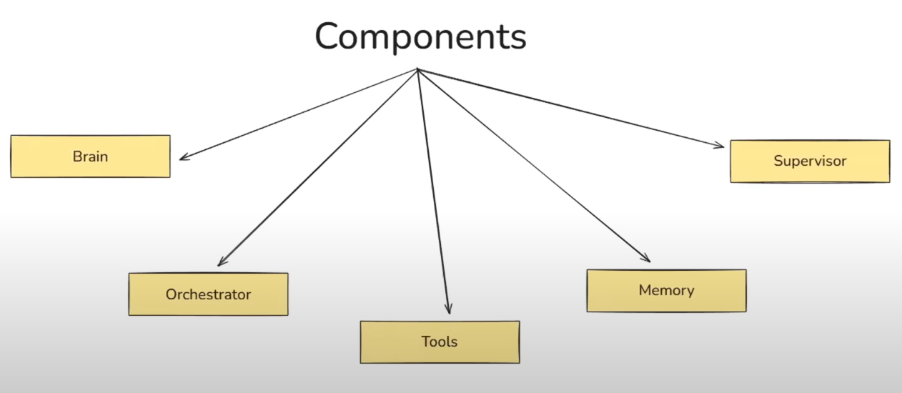
Components of Agentic AI

Brain
Brain is the LLM here that does - Goal Interpretation , Planning , Reasoning , Tool Selection , communication.

Orchestrator
That executes what LLM thinks by LLM. It does Task sequencing , Conditional reasoning , Retry logic , Looping and iteration. The orchestrator is the manager of the task.

Tools
That helps in executing the tasks . e.g. External tools and knowledge base access.

Memory
Short term memory for active session control and Long term memory for past interactions , guardrails .

Supervisor
Entity that lies between AI agent and Human. Approve requests (HITL) , guardrail enforcement and Edge case (Exceptional cases).

Traditional AI is about finding patterns in data and giving predictions while GenAI is about learning the distribution of data so that it can generate a new sample from it.
Generative AI is the building block of Agentic AI.

Gen AI vs Agentic AI
Gen AI | Agentic AI
Creates content based on patterns in data. | Acts autonomously to achieve goals.
Requires user prompts | Operates with minimal input
Gives output in Text, images, code, etc. | It takes Decisions, actions, workflows
Reactive | Proactive and goal-oriented
E.g. Write a poem | E.g. Plan and book a trip
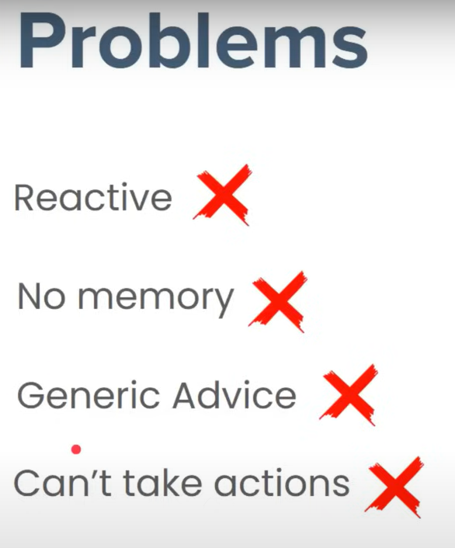

Goal : to hire a backend Engineer !
Chatbot 1 - LLM based chatbot

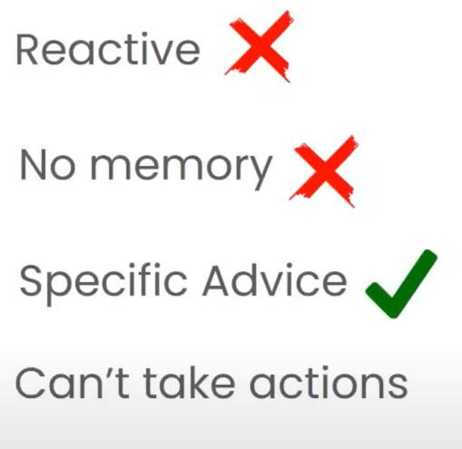

Chatbot 2 - RAG based chatbot

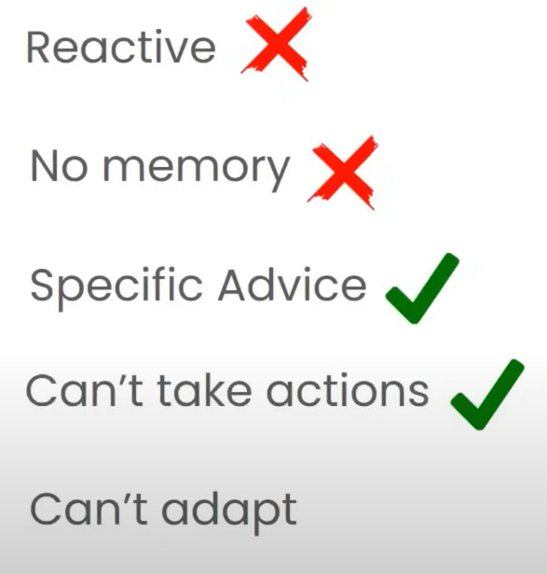
Chatbot 3 - Tool Augmented Chatbot

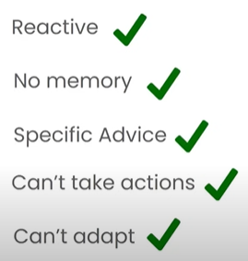
Chatbot 4 - Agentic AI chatbot

